**Open Source Coding OPSC7311**

**Part 1**



GROUP MEMBERS

* Kaushil Dajee - ST10079389
* Avish Judnarain - ST10030291
* Tivolan Velayadum - ST10183038
* Eben Nkulu Mwema - ST10091324

**GitHub Link:**

<https://github.com/IIEWFL/opsc7311-part-1-ST10079389.git>

**RESEARCH 3**

Introduction 3

Overview of applications 3

Toggl Track (Application 1): 3

Strengths: 4

Weaknesses: 5

Innovative feature: 5

Clockify (Application 2): 6

Strengths: 8

Weaknesses: 9

Innovative feature: 9

Timeular (Application 3): 10

Strengths: 11

Weaknesses: 11

Innovative feature: 12

Infographic: 13

Features to be included in our application: 14

Conclusion: 14

**Planning and Design 15**

The requirements of Time Compass include: 16

User Interface Design 18

Project Plan 36

Conclusion 37

REFERENCE LIST 38

## 

# **RESEARCH**

## Introduction

The IIE (2024) argues that the aim of this section is to research three existing time tracking applications currently available on the android operating system and discuss our findings of the three applications as researchers. Our findings will include:

an overview of the applications and screenshots with descriptions, what the researchers believe to be strengths and weaknesses of the three applications, features which the researchers deem innovative within the three applications, a comparison of the three applications using an infographic, a list of the best features according to the researchers, and a brief conclusion of the researchers’ findings.

## Overview of applications

### **Toggl Track** (Application 1):

### 

Figure 1: Welcome Screen | Figure 2: Home Screen | Figure 3: Time entry add screen

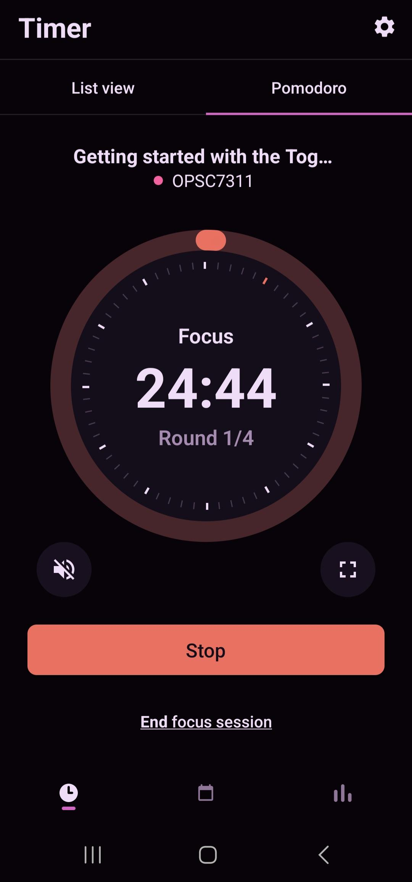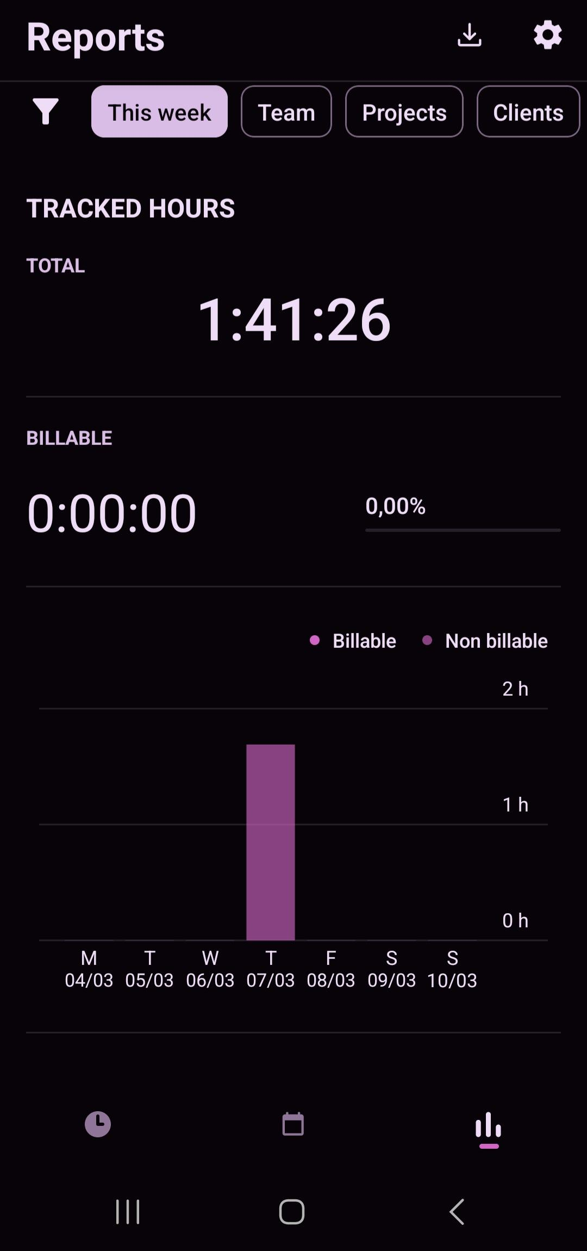

Figure 4: Focus mode Screen | Figure 5: Report Summary Screen

Toggl Track is an easy to use time tracking application aimed at teams of up to 100 people. It's available as a mobile, desktop and web application (Toggl, 2024).

### **Strengths:**

* Toggl Track allows you to create an account using various well known methods, such as email, Google, and Apple.
* Bold choice of a colour scheme, which makes the application standout.
* Syncing across mobile, desktop, and web applications.
* Option to sync with other existing calendars.
* Option to invite other users and start tracking time together as a team.
* A focus mode called Pomodoro, which does x, y, and z,.
* application feels responsive, with little to no delay.
* Option to export a copy of your auto generated reports to various file formats, such as PDF, CSV, or XLS.

### **Weaknesses:**

* Extensive list of features, which can be overwhelming for new users.
* Attempting to create an account or login from the mobile application redirects you to a web page with the login or sign up page.
* Two Factor (2FA) or Multi Factor (MFA) authentication is not supported. Other ways to secure your account on top of a password would make it more secure.

### **Innovative feature:**

* Add billable hours to specific time specific entries and send accurate invoices to clients. You can also view how profitable a project was based on those billable hours.
* Team management. Assign specific roles to team members such as the manager role. With the manager, create time entries for specific members, view reports of hours completed by team members.
* You don't have to download the mobile, desktop or web application in order to use this service. You can download their browser extension which integrates with certain other services like outlook.

Download **Toggl Track** [HERE](https://play.google.com/store/apps/details?id=com.toggl.giskard)

### **Clockify** (Application 2):

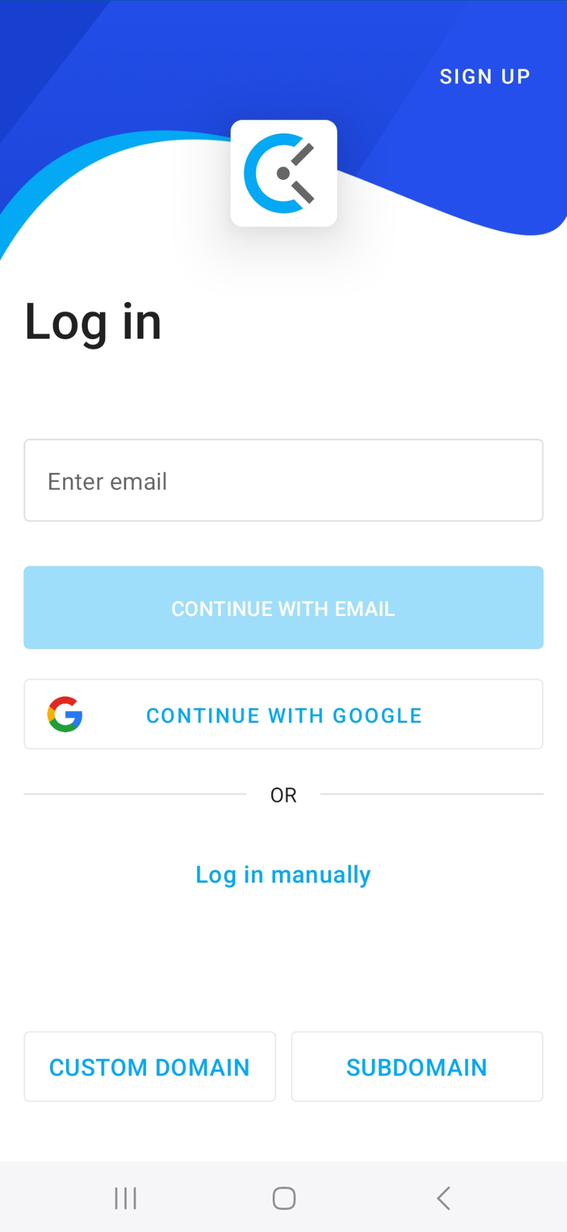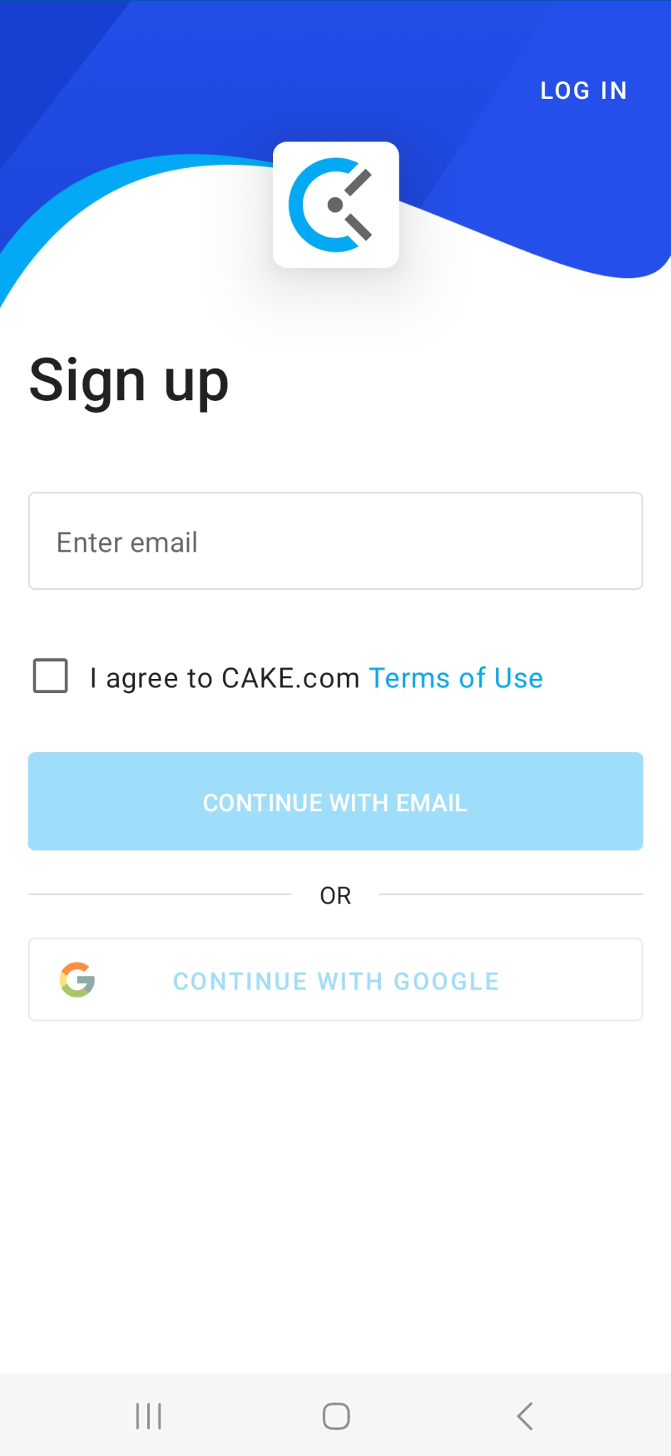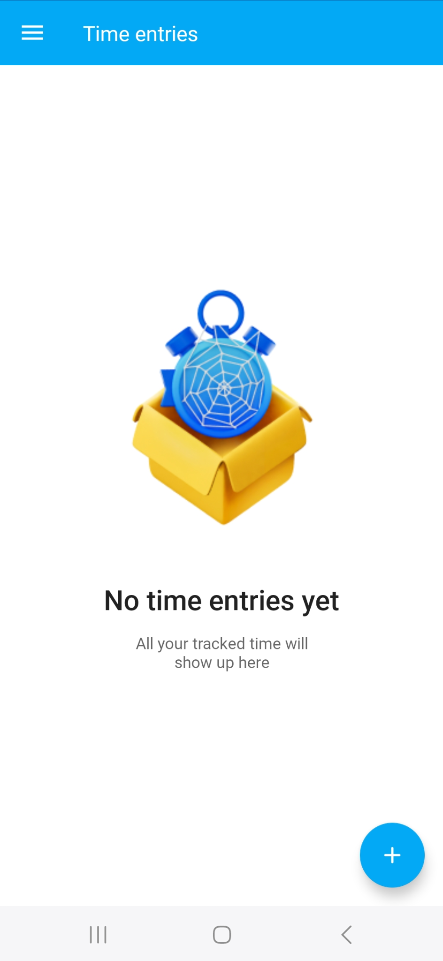

Figure 6: Welcome Screen | Figure 7: Signup Screen | Figure 8: Home screen

#### 

Figure 9: Time entries page | Figure 10: Timer Screen | Figure 11: Add project screen

#### 

Figure 12: Reports screen

Clockify is a famous time following application intended to assist people and groups with following their work hours proficiently. Created by Clockify, the application offers a scope of elements reasonable for consultants, private companies, and huge endeavours. Sent off in 2017, Clockify has acquired far reaching reception because of its straightforwardness, adaptability, and strong usefulness. (Atto, 2022)

### **Strengths:**

* Easy to understand Point of interaction: Clockify offers an instinctive and easy to use interface, making it simple for clients to follow time and oversee projects without broad preparation or specialised skill.
* Adaptability: The application takes special care of different client needs, from individual consultants to huge groups, with its adaptable elements and adjustable settings. Clients can tailor the application to suit their particular work processes and inclinations.
* Practical: Clockify offers a free arrangement with fundamental elements, making it open to individual clients and private companies. Moreover, its superior plans are seriously evaluated, offering astounding benefits for cash compared with comparable time following devices.
* Cross-Stage Similarity: Clockify is accessible on various stages, including the web, work area, and cell phones (iOS and Android), guaranteeing consistent access and synchronisation across gadgets. Exhaustive Revealing: The application's strong detailing capacities permit clients to break down their time

information, distinguish patterns, and make informed choices to further develop efficiency and proficiency. (Cloudwards, 2024)

### **Weaknesses:**

* Restricted Progress Highlights: While Clockify offers many elements, it might miss the mark on cutting edge functionalities found in more particular ventures on the board and time following devices. This limit might influence its reasonableness for complex venture prerequisites.
* Client care: A few clients definitely dislike Clockify's client assistance, referring to deferred reactions and restricted help for specialised questions or issues.
* Security Worries: Similarly, as with any cloud-based application, security and protection concerns might emerge in regards to the capacity and treatment of delicate time following information. Clockify should consistently address and relieve these worries to keep up with client trust and certainty.

### **Innovative feature:**

* AI Bits of Knowledge: Clockify utilises AI calculations to dissect time following information and give significant experiences, for example, distinguishing designs, advancing work processes, and anticipating project courses of events.
* Geolocation Following: The application offers geolocation following highlights that empower clients to follow time in light of their area, especially helpful for field-based or remote work situations where actual presence is required.
* Voice Orders: Clockify upholds voice orders for beginning, halting, and overseeing clocks, improving client accommodation and efficiency, particularly for hands-free energy following. (Appscribed, 2024)

Download **Clockify** [HERE](https://play.google.com/store/apps/details?id=me.clockify.android)

### **Timeular** (Application 3):

### 

Figure 13: Welcome Page | Figure 14: Calendar Screen | Figure 15: Insights Screen

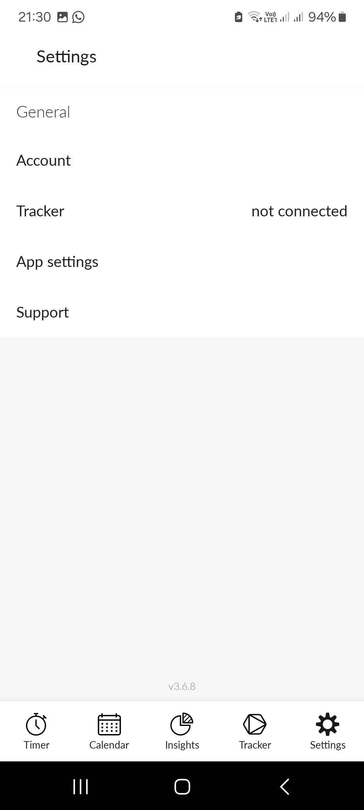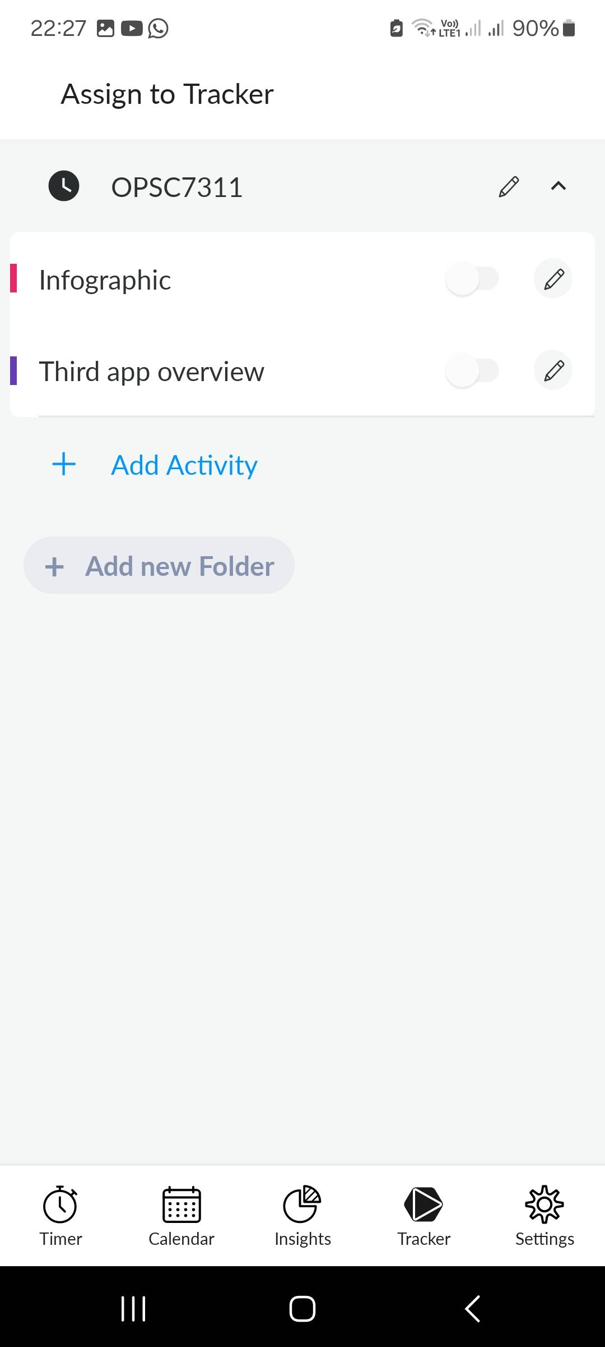

Figure 16: Tracker Assignment | Screen Figure 17: Settings Screen

Timeular is a time tracking application that stands out by making use of the world's first physical, 8 sided time tracking device (Timeular, 2024).

### **Strengths:**

* Clean, minimalistic design. Easy to navigate the application without feeling overwhelmed.
* Cross syncing across all 3 major platforms (Mobile, Desktop and Web applications).
* For mobile applications. Account creation and login is done within the application, not web based.
* You can track more than 8 things at once.

### **Weaknesses:**

* Learning curve - The actual collaboration and customization choices of the Timeular Tracker might introduce an expectation to learn and adapt for certain clients, especially the individuals who are familiar with customary computerised time following techniques.
* Compatibility issues - The Timeular Android application might experience similarity issues with specific Android gadgets or working framework variants, prompting potential execution issues or constraints in usefulness.
* Cost - While the Timeular Android application itself might be allowed to download and utilise, the related expense of buying the actual Timeular Tracker gadget and premium membership plans can be somewhat high contrasted with other time following arrangements.

### **Innovative feature:**

* Mobile accessibility - The Timeular Android application furnishes clients with advantageous admittance to time following highlights on their cell phones, empowering them to follow time in a hurry.
* Offline functionality - The Timeular application offers disconnected usefulness, permitting clients to follow time and access specific highlights even without a web association.
* Customizable activity mapping - Timeular permits clients to characterise their own exercises and allot them to various sides of the Timeular Tracker.

Download **Timeular** [HERE](https://play.google.com/store/apps/details?id=com.tmlr.zei.production)

### **Infographic:**

### 

Figure 18: Time Comparison Infographic (Mwema, 2024)

### **Features to be included in our application:**

* An option to log in using a username and password. Taken from all applications. This will allow us to store user data somewhere when memory is freed and then load the data again whenever the user requests it.
* An option to add categories for time entries. This will organise time entries and make it easier to manage and view time entries.
* An option to view a list of all time entries created within a specific time period. This will help users keep track of their uncompleted, on-going and completed tasks.
* An option to view a graph of the completed total hours of all or specific time entries for the week. This will help users gauge how well productive they are with their time as well as how they can improve their productivity.
* An option to translate text to a language/s other than English. This will accommodate more users and increase downloads of our application by non-english speaking individuals or multilinguals.

### **Conclusion:**

After analysing the three applications (Toggl Track, Clockify and Timeular) we have realised that our application needs to be appealing and easy to use to gain mass adoption. We will therefore go for a modern and minimalistic design with a colour palette such as the one in the infographic above.

## **Planning and Design**

Our time management app's aim is to enable users to easily organise their daily schedules and increase productivity. With the help of this user-friendly tool, users can efficiently plan, organise, and track tasks, maximising their time. Through encouraging proactive time management, our app seeks to improve productivity, lessen stress, and ultimately assist users in leading more balanced and satisfying lives.

Our app will be called "Time Compass," and it will depict a person who effectively controls their time as moving in the right direction. Below is our chosen app icon. This icon was designed using different UI principles, such as sticking to a minimal design as well as using clear, visible text and our colour scheme follows a minimal design.

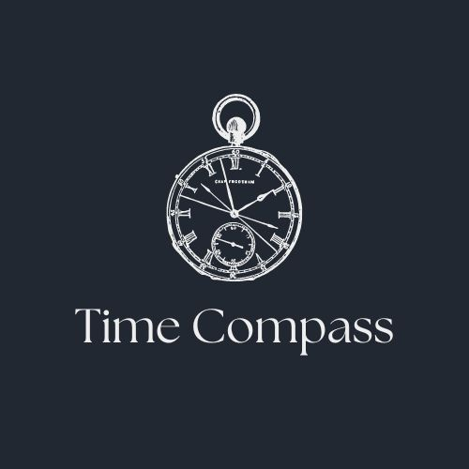

Time Compass plans to offer many features, our app's intuitive features, which include adding tasks, setting their due dates as goals, tracking these tasks , plenty of customizability within the app, notifications for tasks due soon, and a reward-based system, make it simple for users to define priorities, and track their progress while everything feels more personal to the user. The innovative reward-based system makes time-management fun for the user.

### **The requirements of Time Compass include:**

* **Log in / sign up:**

A user will be met with a minimal login and sign up screen, which will make the user want to use the app as they are able to log in easily. Or they may create an account and use the app as normal.

* **Forgot password (from research):**

Some users may forget their password, which is why we have to account for this and give them a forgot password option to change it or get it back.

* **Timesheet Entries:**

The user will be able to make something called a timesheet entry, which will include the date of the timesheet entry, the expected start date of the task, the expected end date of the task, a description of what the task is about and what's to be done, and the category of the timesheet entry. This will be basically a form filled out for each task entered.

* **Categories:**

All timesheets will not be related, this is why we will classify and separate each timesheet entry into a respective category, such as based on a specific module.

* **Photographs:**

Users can upload a photo to each timesheet entry they make. Such as a motivational quote, or maybe they could track their progress visually over time by updating timesheet entries for the same task, in which case they can keep adding pictures with every entry made.

* **Daily Goals:**

The user should be able to set a minimum and maximum number of hours daily for the current active tasks. This is where users will earn points to level up based on their performance. For example, a user who reaches their maximum daily goal will earn more points than someone who reaches their minimum daily goal.

* **List of tasks:**

If you click on a specific category and then the name of a specific task, you should be able to see all the timesheet entries made under that task, if there are multiple. Where photos were added to these timesheet entries, they should be viewable by the user.

* **Category hours:**

The user should be able to see the total number of hours spent on every different category while working on tasks. Apart from seeing the total, the user should be able to see the total hours spent on a category between a range of dates.

* **Graph:**

A line graph should be displayed within the final application, representing the total hours worked each day by the user over a range of dates. This will be a single line on a line graph; there will be two other lines on the graph, representing the number of hours for the maximum and minimum daily goal.

* **Visual format of progress:**

The final app will display visually in a pie chart the percentage of time the user has achieved between their maximum and minimum daily goal, which will increase their productivity, which is the heading of the pie chart. Any time the user works less than their minimum daily goal, it will decrease their productivity.

* **Online Database:**

The final app has an online Google Firebase database for improved performance and makes the app usable on any device.

* **Dashboard:**

The app will have an interactive dashboard where they will find everything they need in one place to prevent some features from being missed.

* **Minimal Design:**

According to Medium(Victory Brown,2022) a minimal design is easier for the user therefore, we went for a minimal design as it improves users focus, which is in line with the principles of time management, with the use of a minimal design interface we offer a simple, and distraction-free environment where users can manage their time effectively.

* **Notifications:**

According to Dribble(Etheric agency, n.a.) a well-designed notification encourages users to accomplish their time-related objectives so we implemented a simple notification design the user will surely notice.

* **Reward-based system:**

Our reward system, which will gamify the app and make it fun for the user. Users will all start at level one, and when they set a target date to complete a task, they will receive a few points for setting any goals that will contribute to their level, which can help them level up. If they complete this task before the expected date or exceed maximum hours daily, they will earn more points to level up.If they complete the goal on the target day or in between maximum and minimum daily hours they will earn some points, but if they complete it after the target day or below minimum daily hours, they will ultimately lose points and possibly level down.Which will contribute to a global leaderboard that will display the highest level users, as well as a separate leaderboard for friends, making it competitive among users and their friends, keeping them on track towards their personal goals while having fun.

### **User Interface Design**

**Login Page**:

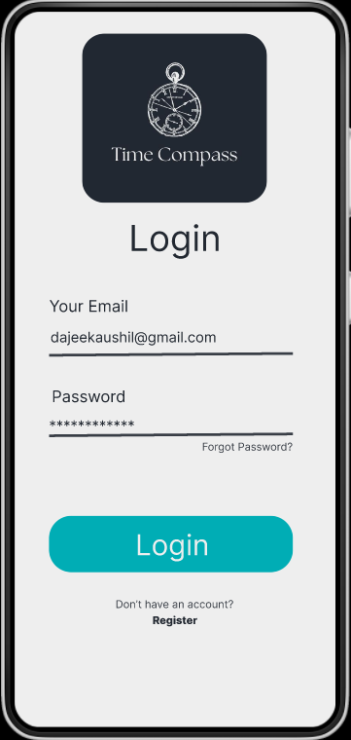

This is the first page the user will see when they open the mobile application. The login page, which requests that the user enter their credentials. If they forgot their password, they can click the “Forgot Password?” text, which will take them to another page to view their password. If the user doesn't have an account, they can click the “Register” text to create one.

**Registration Page**:

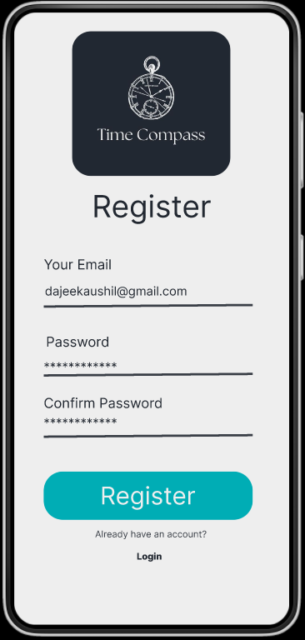

To register an account the user must enter their email and password and confirm their password to successfully create their account.

**Forgot Password Page**

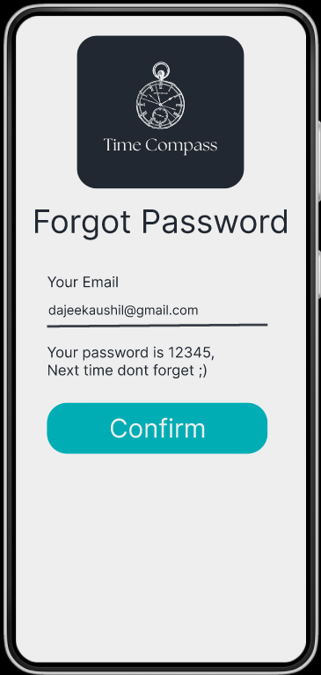

If the user forgets their password the application will take them here to enter their email where we will reveal their password if their email is correct.

**Home Page**

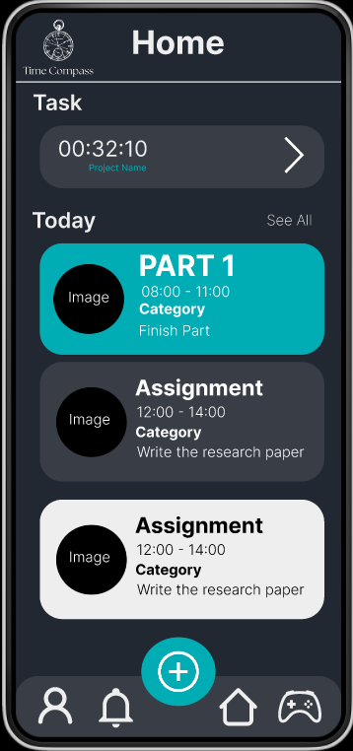

This will be the home page where the user ends up if they successfully make an account. All Tasks due soon will be displayed here at the main page. From here you will have the options of accessing the other pages and features.

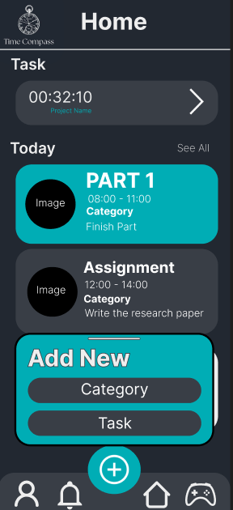

When the user clicks the plus icon they are able to choose what they would like to add. A category or a task.

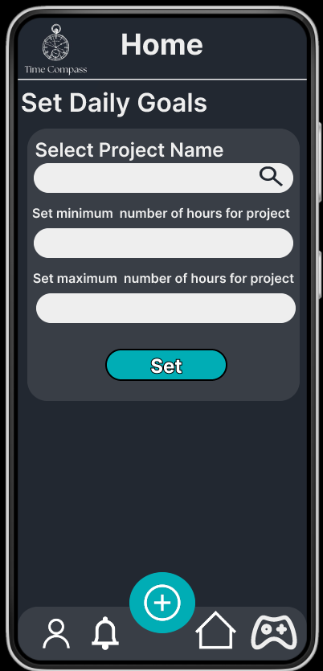

If the user scrolls down they are able to set their daily goal for a project.

**Add Category Page**

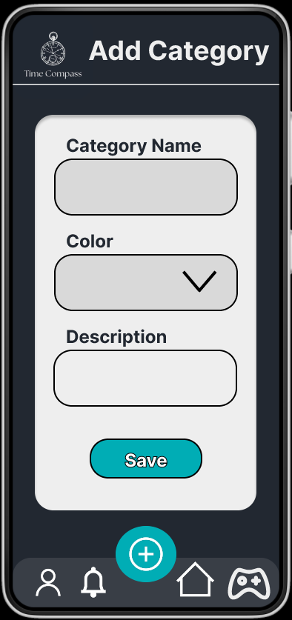

Here, the user is able to add details to save a category.

**Add Task Page**

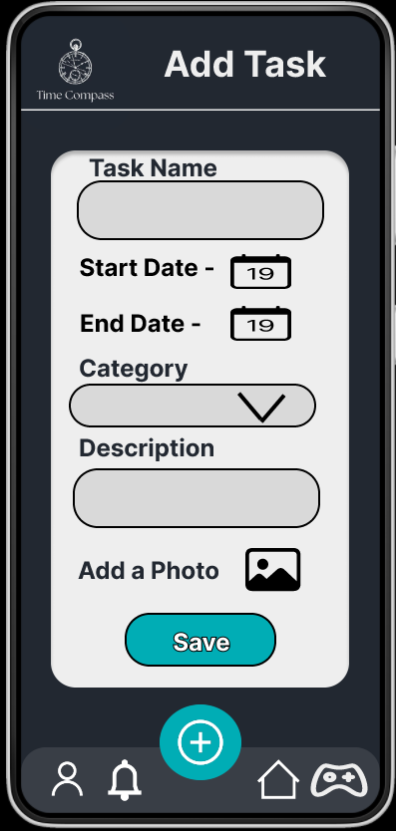

Here, the user is able to add details to save a task within a specific project.

**Categories Page**

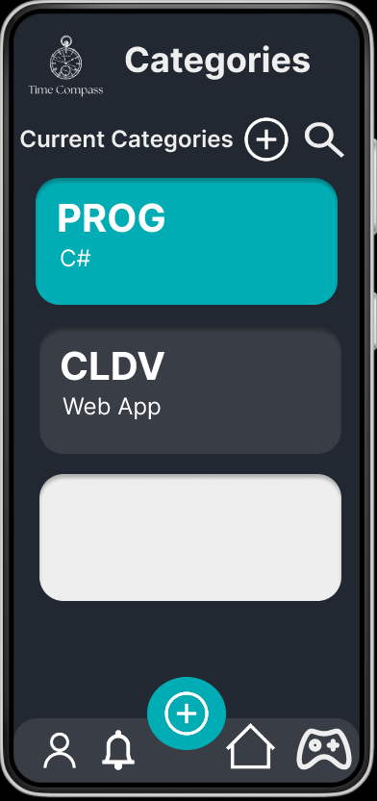

On this screen, the user can view all categories saved.

**Tasks Page**

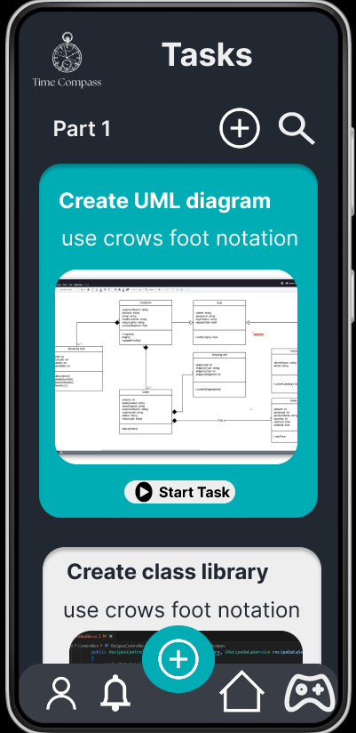

On this screen, the user can view all the tasks saved for a specific project.

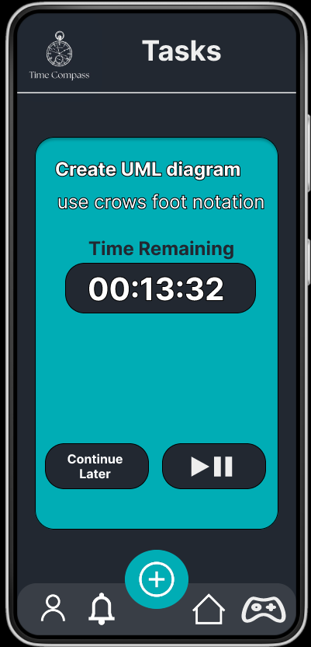

This is the time tracker for when a user attempts to complete a specific task.

**Account Page**

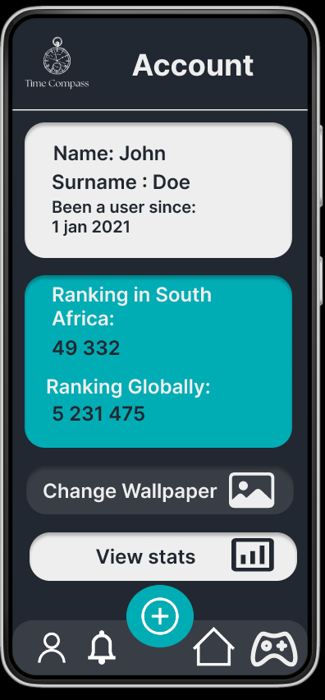

This is where the user will be able to view their account information, like their personal information, stats, or even customise the application.

**Stats page**

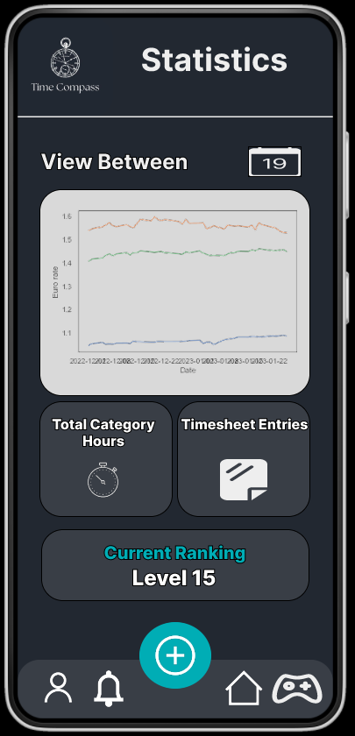

This is the stats page where the user will be able to view all their stats from using the application. Such as the total category hours and timesheet entries for a specific period.

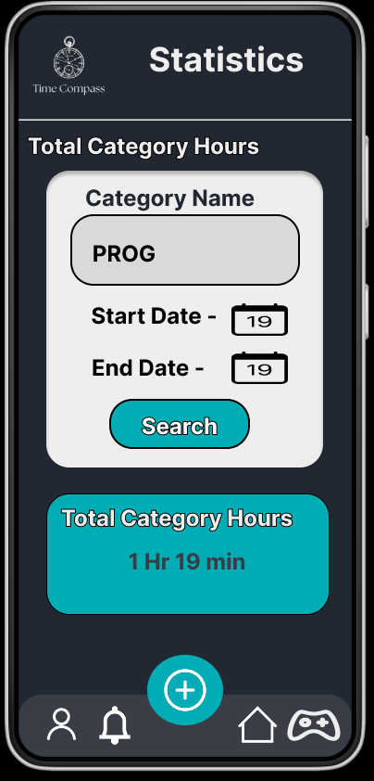

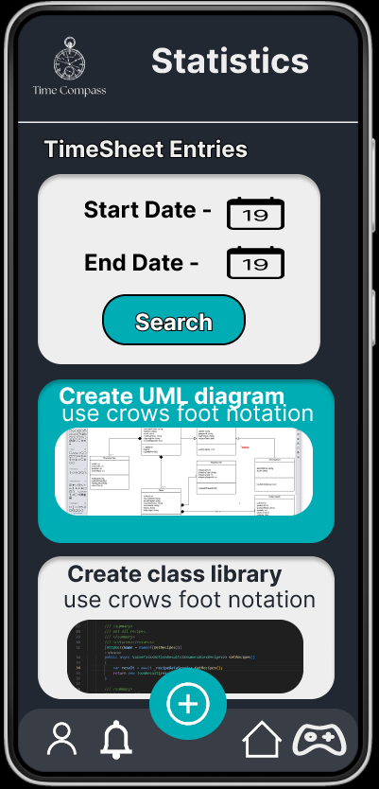

**Notification Page**

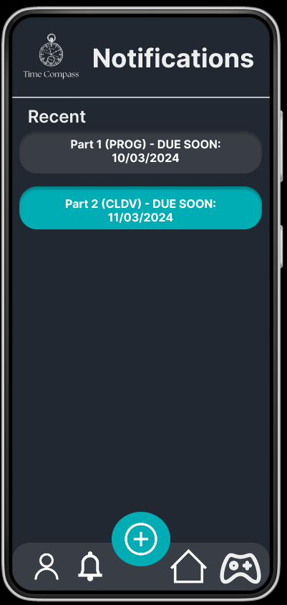

This is the notification page where the user can view all missed notifications about anything due soon.

**Game Page**

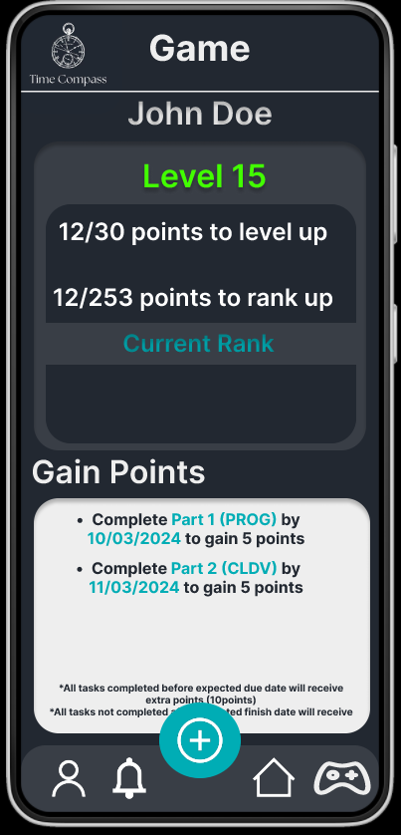

This is the game page where the user will be able to play against other users.

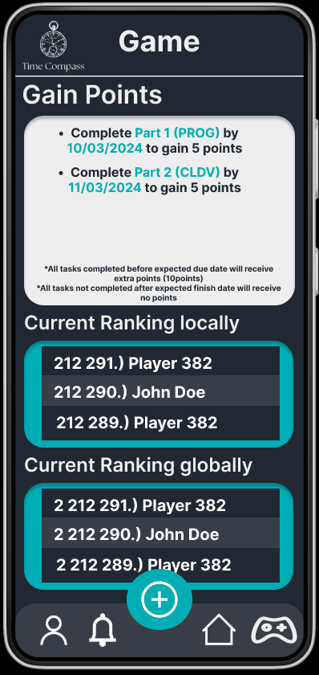

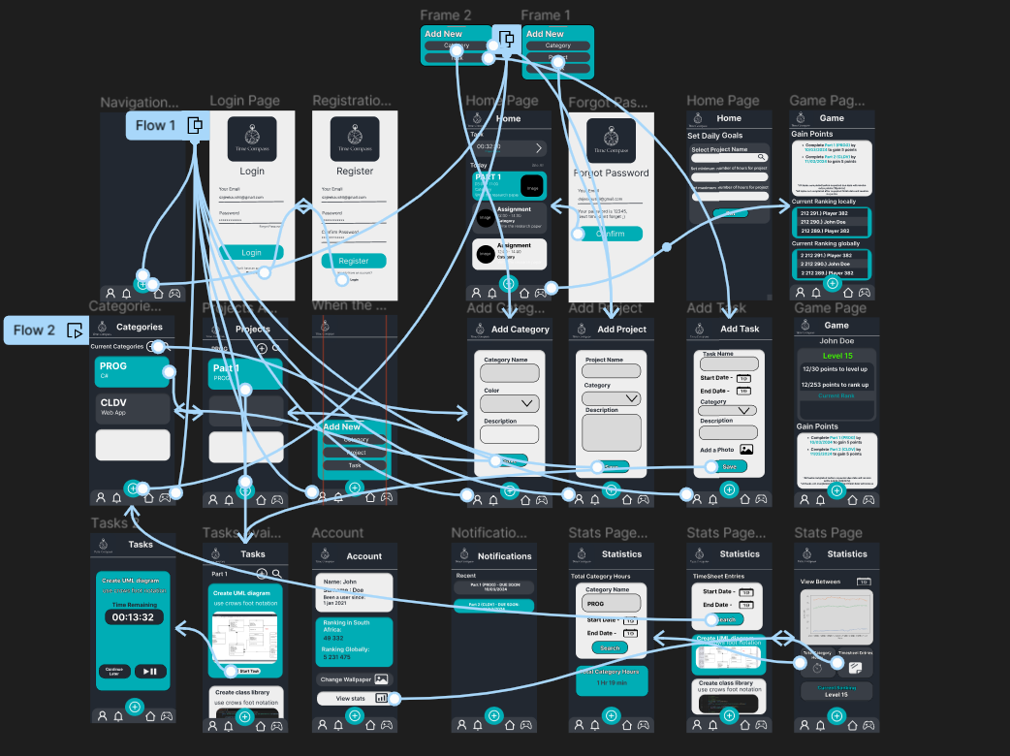

Shows how the user will navigate across the app.

### **Project Plan**

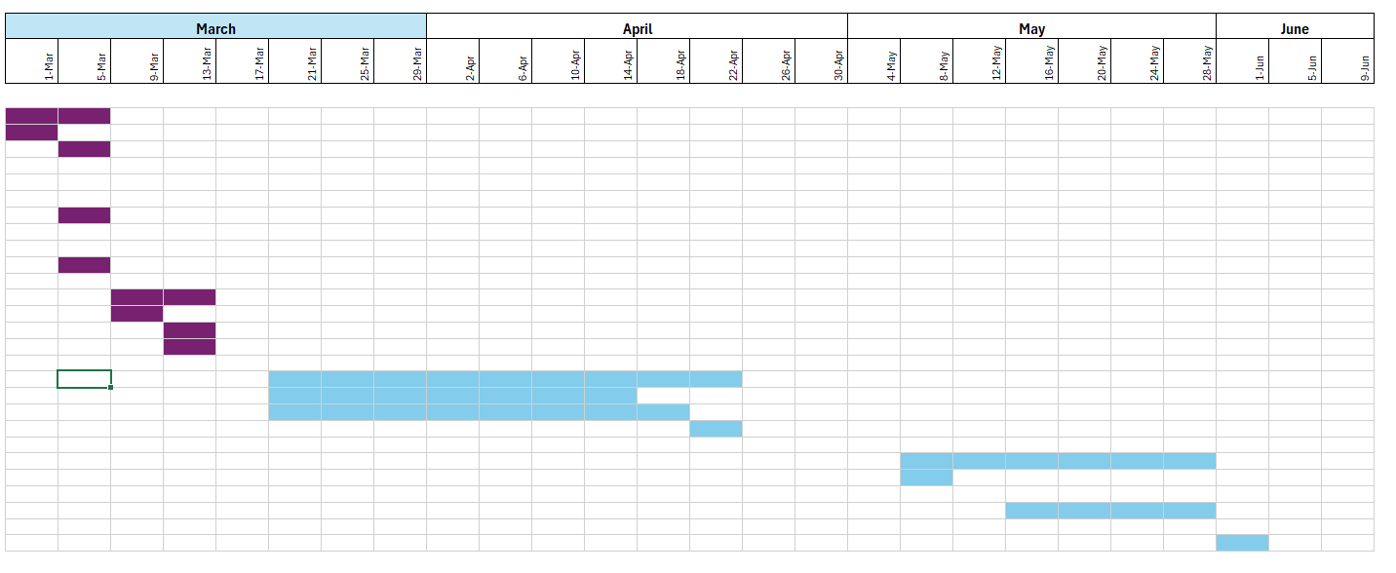

Timeline Purple indicates it is done, and blue still needs to be completed.

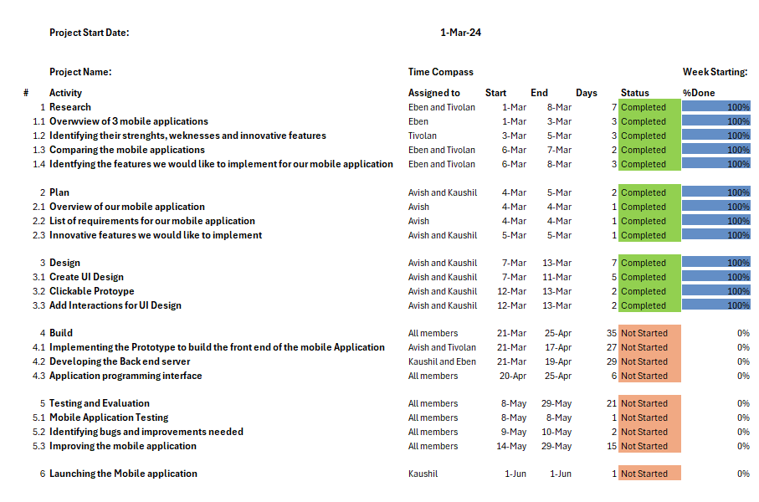

### **Conclusion**

After research and planning, we have identified the best features of the apps and selected what we would like to add to our own application, which will make us a better option compared to the other time tracker apps, as ours does not just focus on productivity; it rewards you for being productive. The design process was the most important part, as we wanted to give the user an experience unlike any other time tracking apps by making it very minimal, easy to understand, and easy to navigate the application while making it easy to stay consistent. Time Compass was designed with the mission to not only encourage productivity but to also keep the user consistent with using the app.

### 

### **REFERENCE LIST**

The IIE. 2024. Open Source Coding [OPSC7311 Portfolio of Evidence]. The Independent Institute of Education: Unpublished.

Toggl. 2024. Frictionless time tracking software for teams, s.a. [Online]. Available at: <https://toggl.com/> [Accessed 17 March 2023].

Timeular. 2024.Time tracking and leave management redefined: effortless, smart, secure, s.a. [Online]. Available at: <https://timeular.com/> [Accessed 17 March 2023].

Mwema, E. 2024. Infographic diagram. [Personal drawing]. Johannesburg. Unpublished.

Zuckerman, A. (2020) *Clockify Reviews: Pricing, pros, cons & features*, *CompareCamp.com*. Available at: <https://comparecamp.com/clockify-reviews-pricing-pros-cons-features/#:~:text=Main%20features%20of%20Clockify%20are%3A%201%20Time%20Tracker,Timesheet%206%20Dashboard%207%20Reports%208%20Team%20Management> (Accessed: 23 March 2024).

*Clockify Review: Streamlining Time Tracking for teams* (2023) *Appscribed*. Available at: <https://appscribed.com/software/clockify-review/> (Accessed: 23 March 2024).

(No date) *6 best time tracking apps for Android in 2023*. Available at: <https://attotime.com/blog/time-tracking-app-for-android> (Accessed: 23 March 2024).

Dan Ginn (Writer)— Last Updated: 13 Feb’24 2024-02-13T12:27:26+00:00 Facts checked by Jasna Mishevska *et al.* (2024) *Clockify Review 2024 [is it really free?]*, *Cloudwards*. Available at: <https://www.cloudwards.net/clockify-review/> (Accessed: 23 March 2024).

Brown, V. (2022). *Why should minimalism be considered in design?* [online] Medium. Available at: <https://uxplanet.org/why-should-minimalism-be-considered-in-design-cdfaaa42ae8c>.

dribbble.com. (n.d.). *NFT Marketplace - Mobile Notifications*. [online] Available at: https://dribbble.com/shots/21040954-NFT-Marketplace-Mobile-Notifications

[Accessed 24 Mar. 2024].